R.D.R PROJECT

3ºAno – 1º Semestre

Aulas Teórico-Práticas

laboritory

Docente:

Paulo Torres

Edição revista:

Paulo Torres

**Summary**

1 Introduction 3

2 Database 3

2.1 conception 3

2.2 Creation of database 4

3 Python script 6

4 Webpages 7



# Introduction

In this document, We will talk about the webpages of R.D.R project. The goal of my work is to create Webpages, database and python script for the customer can see all information about our stock of object. He can watch, edit, add and remove object in the webpage.

Also, we receive data in TXT file that come from python script. We need to add this element in database. Finally, we need to create python interface to add element in database.

To meet this need, we use some technologies:

* PHP, CSS, JS, JQuery: language use for Web architecture (more details in web architecture report)
* Python: creation of script to add transfer data in txt file to database and creation of python interface with Tkinter to add element in txt file
* Anaconda with spyder: IDE to develop and execute python language
* MySql: database to store object value
* PhpMyAdmin: interface to manipulate with MySql database
* Wamp: Local webserver

First let’s talk about Database.

# Database

## conception

For this project, we didn’t need complex database architecture, I choose to create only one table “Objects” with column:

* object_id
* object_name
* quantity
* brand
* place
* year

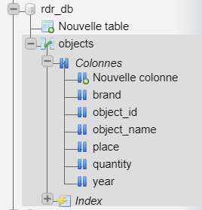

Fig 1: Conception of rdr_db

This table is creating into “RDR_DR” database. The object_id is a primary key, i.e that need to be unique. Also, it is in AUTO_INCREMENT, i.e everytime you insert new object in database, object_id will be automatically created and have unique value. Value is increment 1 by 1.

## Creation of database

If you want to create same Database, you need to create manually the database BUT not table and data. For that, we have script.

To create database, you need to go on PHPMyAdmin. If you have installed Wamp, you need to launch it. Go on <http://localhost/phpmyadmin>. You need to authenticate, by default is root with any password.

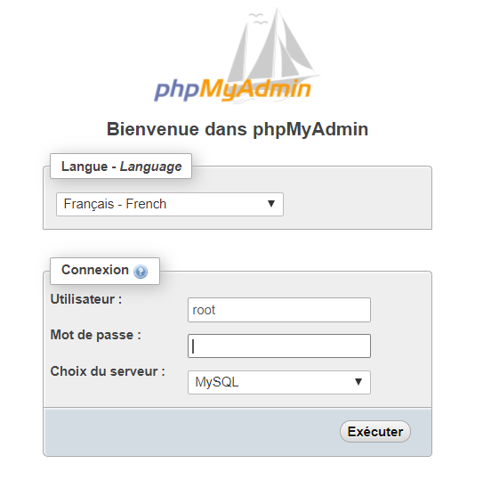

Fig 2: Auth page PHPMyAdmin

After you are connected to the interface, you need to click on “create new database”.

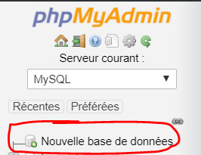

Fig 3: Create new database

Write the name of Database, “RDR_DR” and click to the validation button.

To create table and insert data, we have SQL script. You need to click on your database and go to “SQL” tab.

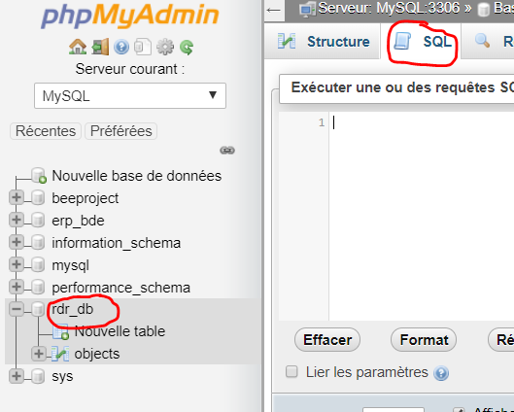

Fig 3: SQL tab

Script SQL: [..\..\..\Downloads\rdr_db (1).sql](../../../Downloads/rdr_db%20(1).sql)

You need to copy all SQL file into SQL tab and click to execute. Normally, after that, you can show your database.

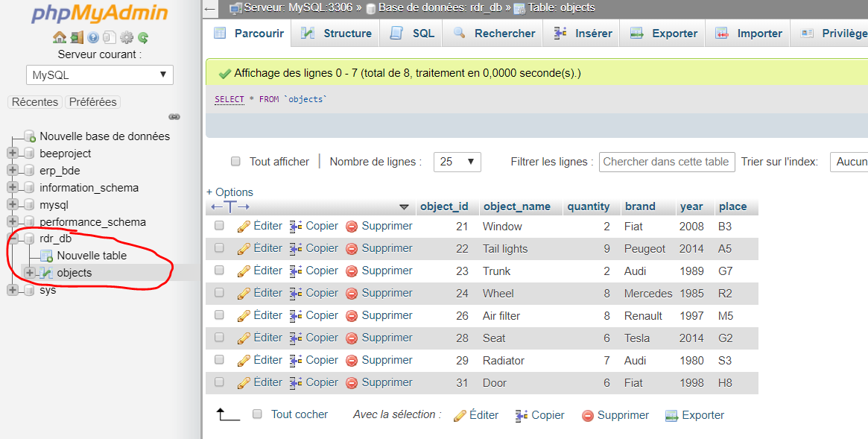

Fig 4: object table with values

Now, your database is creating, we will see the python script to insert data in TXT file and database.

# Python script

For the script, we use two external modules, if they are not installed, you need to download it. The modules are “mysql-connector-python” and “tkinter”. The first is to connect your python script into your mysql database. And the second is to create interface in python.

If you use anaconda, you can download it with this command:

conda install -c anaconda mysql-connector-python

conda install -c anaconda tk

The first script in python called “insert_object.py” is used to insert new objects in TXT file. It’s simple interface with tkinter. We just need to fill all input and click to insert. The code takes care of converting input to good format and inserting into file. The format in TXT file is like:

Object_name;quantity;brand;year;place

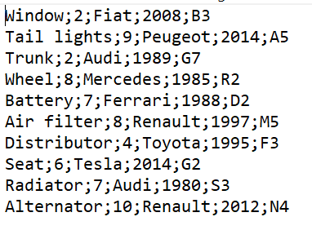

Fig 5: format in TXT file

If you want to know more about this code, you can show it. I explain with comments all functionalities.

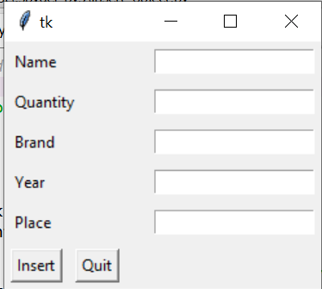

Fig 6: adding object interface

The second python script called “RDR_script.py” is used to transfer data on TXT file into database. The code is very easier to understand. First you create connection to database and open the TXT file.

After that, you create table “objects” if doesn’t exist. You iterate all rows in txt files, you split all values and insert it into database. Rows in TXT automatically removed after inserting in database. Finally, you close database and file connection.

If you want to know more about this code, you can show it. I explain with comments all functionalities.

Now you can insert data in database, we will see how to see all data in webpage and manipulate it.

# Webpages

This is the most interesting part. The goal is to create table with all object in database and manipulate it. We have some functionalities like:

* filtering table
* add object
* edit object

The web architecture is structured by MVC design pattern; If you wan to know more about this pattern, you can show the “Web architecture” report. We have more details about this architecture and the code.

If you want to see webpages, you need to copy all the repository “RDR_template” into your “www” repository if you are using Wamp. By default, the path is C:\wamp64\www.

Go to <http://localhost/RDR_template/controller/index.php>

You will see this page:

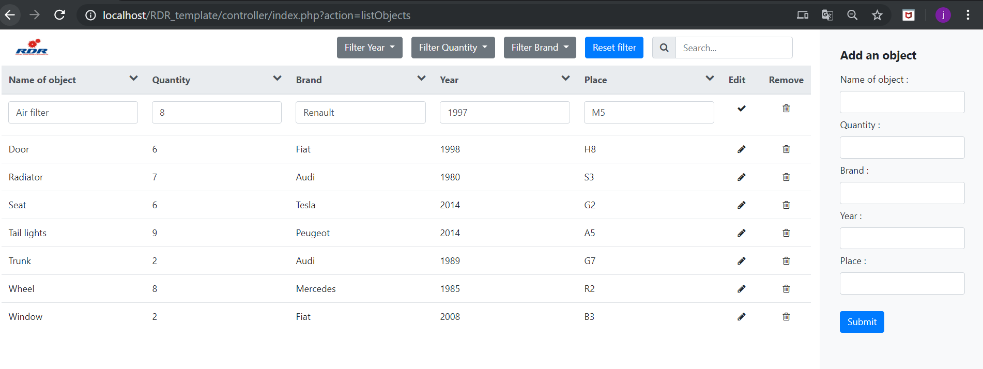

Fig 7: RDR main page

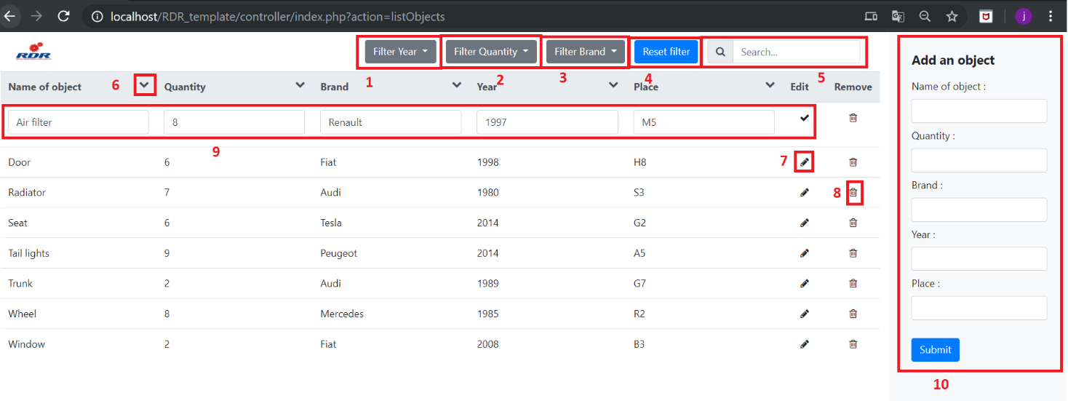

Fig 7: RDR main page with functionalities

1: Filtering table by year with max and min value

2: Filtering table by quantity with max and min value

3: Filtering table by brand with dropdown selection

4: Reset Filter

5: Search bar to find object with specific research

6: Ordering each column by ascendant or descendant sort

7: Edit button click

8: Remove object into table and database

9: Editing object when you have clicked into editing button. To confirm, click on check button at same place of edit button

10: Add new object on table and database

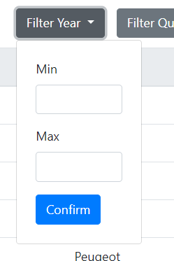

Fig 8: Min - Max dropdown interface

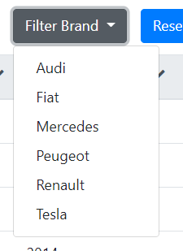

Fig 9: brand dropdown interface

If you want to create new object but the name is same than other item in database, you will have a conflict.

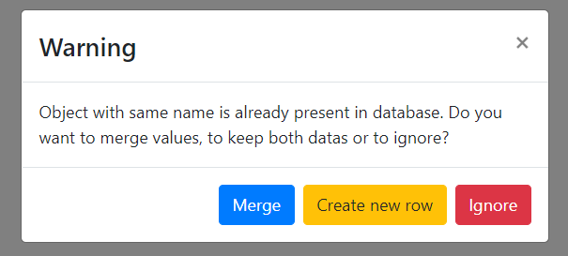

Fig 9: Popup same object in database

You have three choice:

* Merge: you will merge the two objects and add quantity and place column
* Create new row: Create new object and keep the two elements
* Ignore: Ignore insertion of new object